**1. Solution 1**

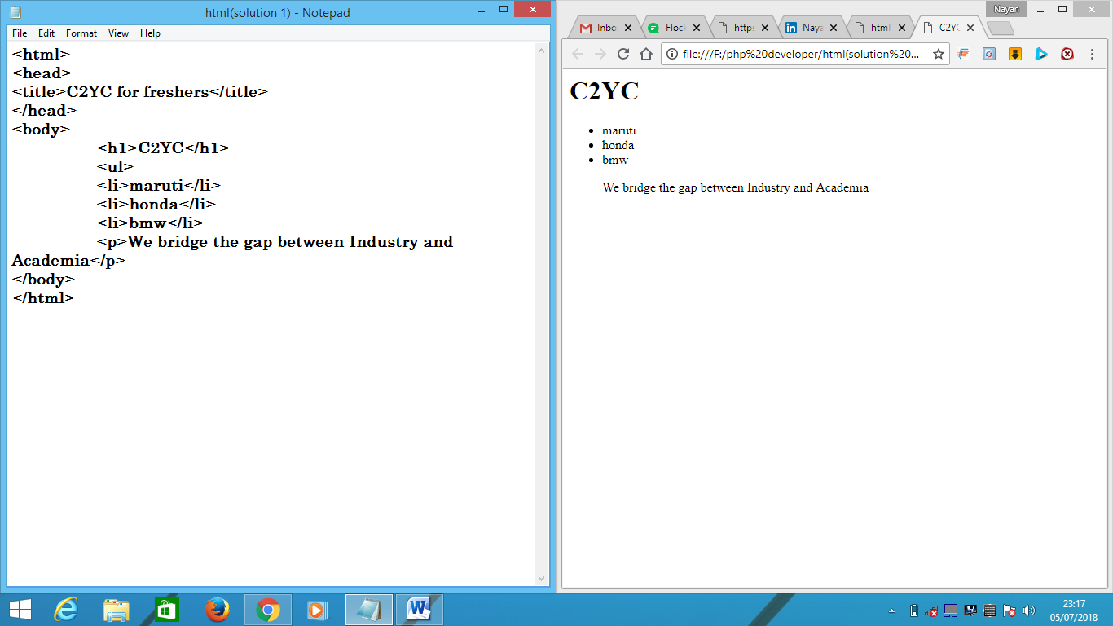

**Solution 2:**

<html>

<head>

<title>C2YC for freashers</title>

</head>

<body>

<h1>Login</h1>

<b> Please enter your username and password</b>

<br>

<br>

<input type="text" placeholder="Username" name="username"/>

<br>

<input type="password" placeholder="Password"name="password"/>

<br>

<input type="submit" value="Submit"/>

<br>

<br>

<a href="html(solution 1).html">Forgot Password</a>

</body>

</html>

**Solution 3:**

<html>

<head>

<title>C2YC for freshers</title>

</head>

<body>

<h1>Login</h1>

<b>Please enter your username and password</b>

<br>

<br>

Username<input type="text" placeholder="Username" name="username"/>

<br>

Password<input type="password" placeholder="Password" name="password"/>

<br>

<input type="submit" value="Submit"/>

<br>

<br>

<a href="html(solution 2).html">Forgot Password</a>

</body>

</html>